Practical - 2
Practical Title: Semantic HTML5 Pages with Accessibility-Ready Structure
Problem Definition Develop static HTML5 skeletons for at least 10 Student Hub pages such as Home, About, Register, Login, Dashboard, Events, Profile, Contact, Admin, FAQ, and Feedback. Use semantic tags and accessibility-friendly structure.

A.Theory
1. Are semantic tags such as header, nav, main, section, article, aside, and footer used properly?
Answer: Yes I have used all the tags properly ,header for header section like as footer for footer of page. Nav for navigation bar ,main for main content of body and everything else.
Source: Geeksforgeeks

2. Are form labels, headings, image alt text, and navigation links accessible?
Answer: Yes , Everything is accessible + easily readable by user who uses this website.
Source: W3School

3. Is the page structure consistent across all pages?
Answer: Almost Every Page have same structure like first header then nav bar then main content and at last footer of webpage.
Source:MDN Web Community

B. Implementation/ Output/Result
In this practical, I applied semantic HTML tags like header, nav, main, article, aside, and footer. These tags help organize a webpage in a way that makes sense, instead of just using plain div elements everywhere. The header usually holds the logo and title, nav holds the menu links, main holds the important content of the page, article is used for content that can stand on its own (like a blog post), aside is for extra content like a sidebar, and footer holds things like copyright info at the bottom. Using these tags makes the website easier to read for both developers and screen readers, and also helps search engines understand the page better. I also learned why we write DOCTYPE html at the top of every HTML file — it tells the browser that the page is using HTML5, so the browser displays it correctly instead of showing errors or weird formatting.

C.Evidence Of Work(Screenshots)
1)Home Page:
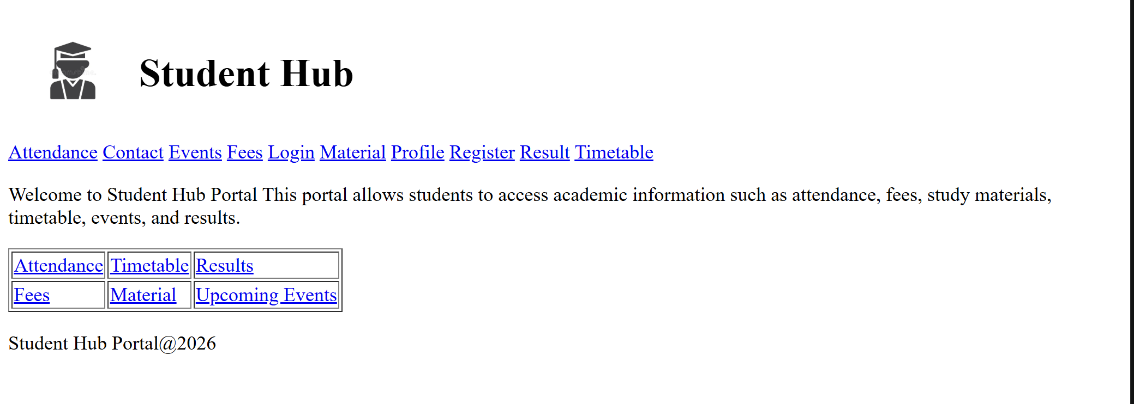

2)Login Page:
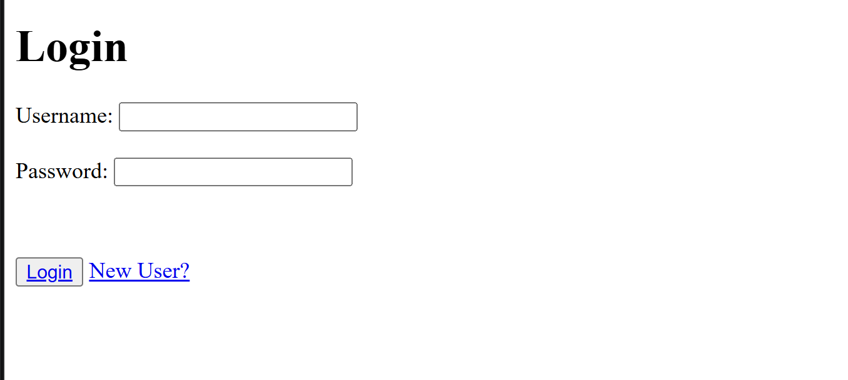

3)Register Page:
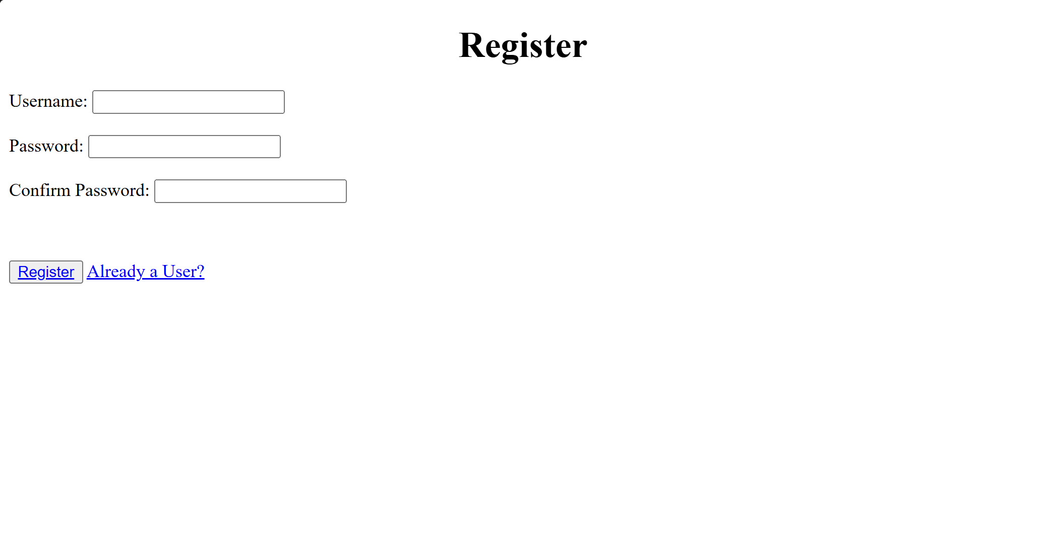

4)Attendance Page:
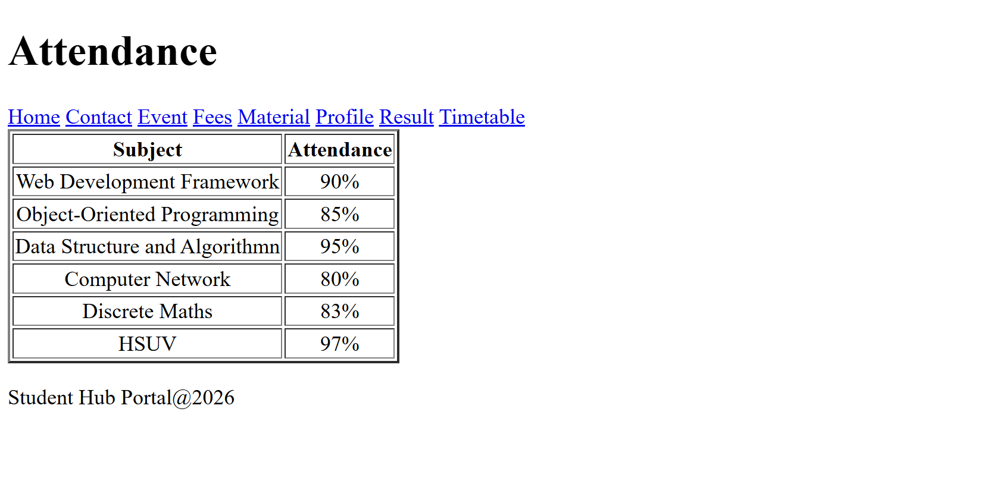

5)Contact Page:
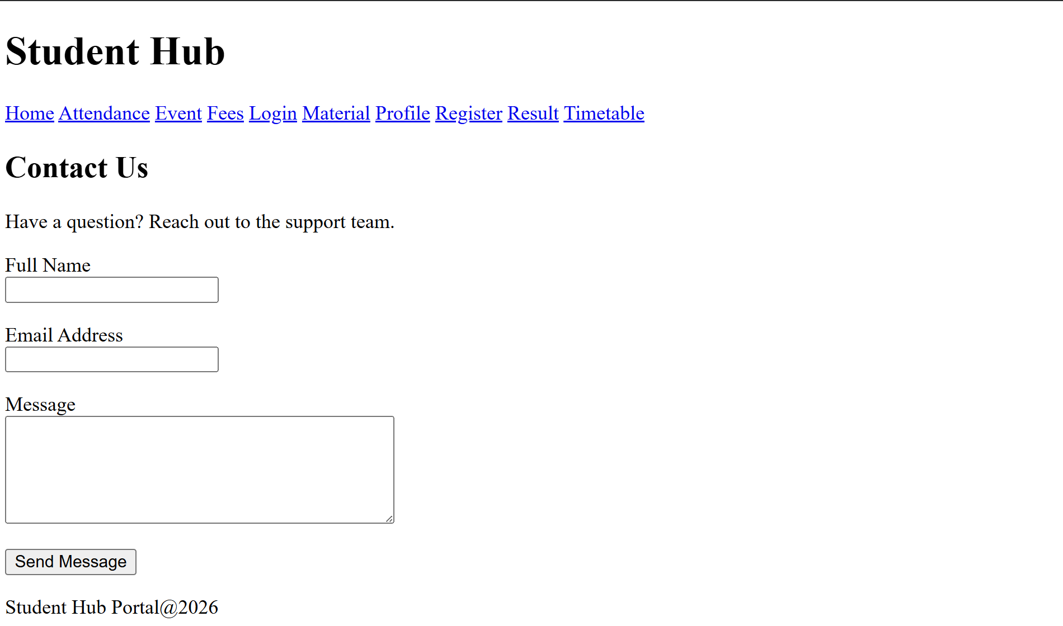

6)Details(Event) Page:
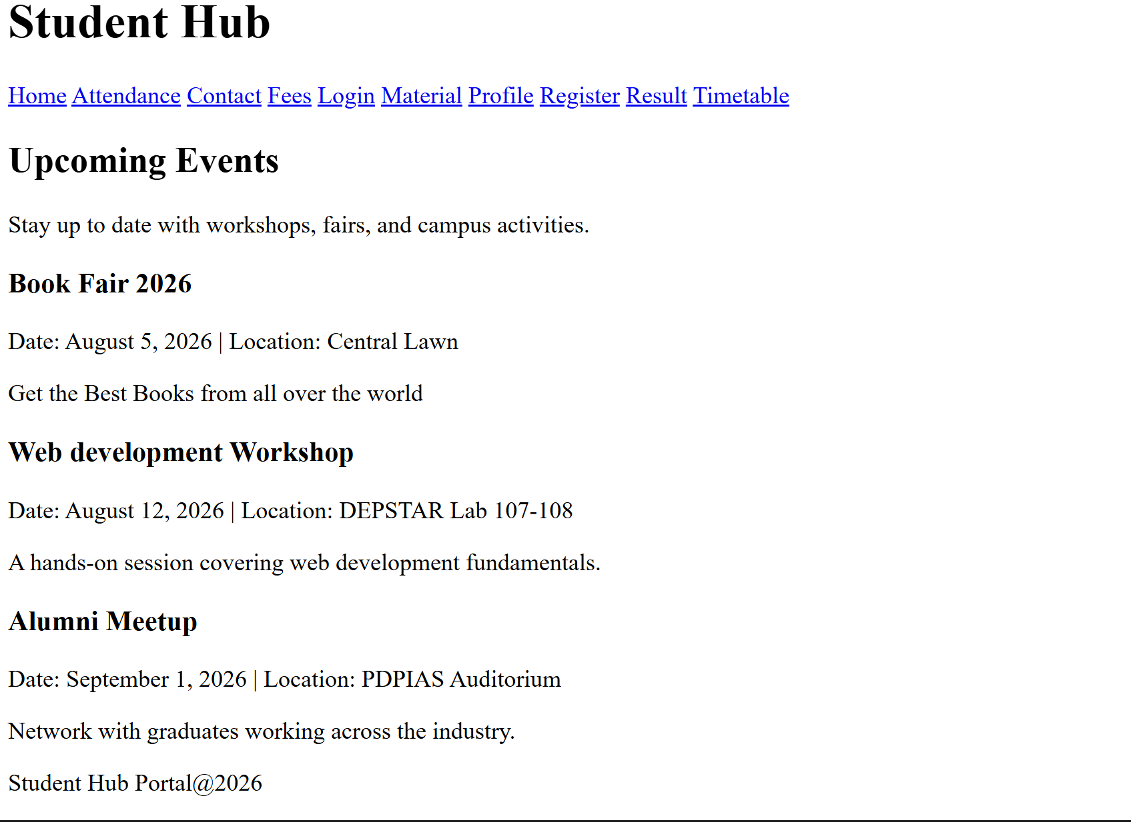
7)Fees Page:
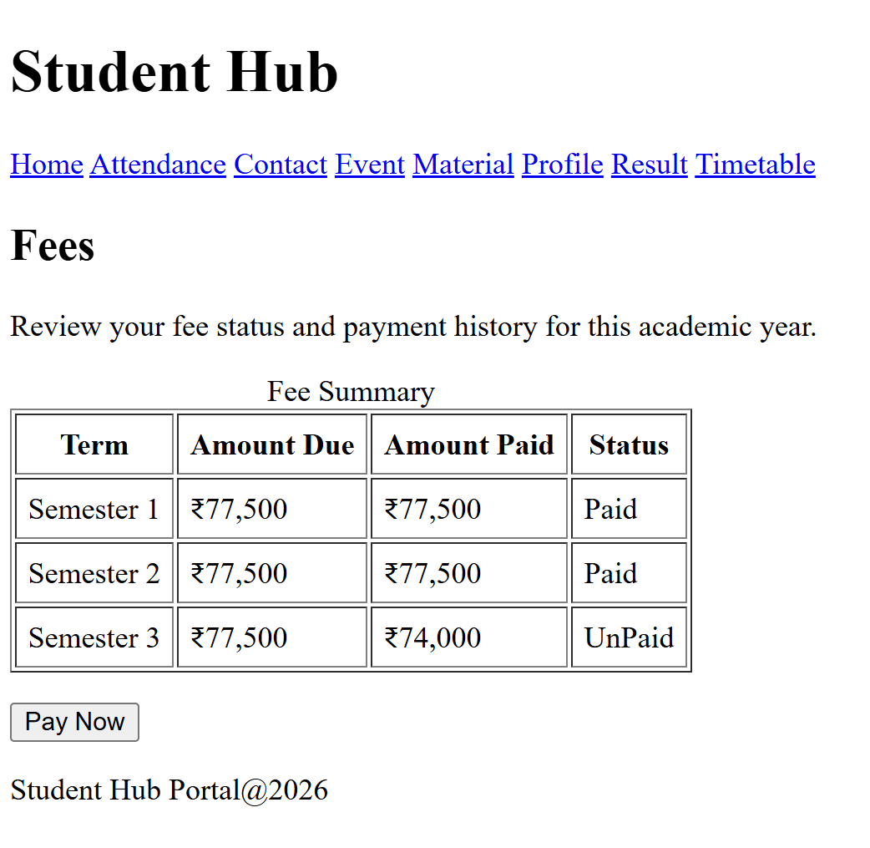

8)Material Page;
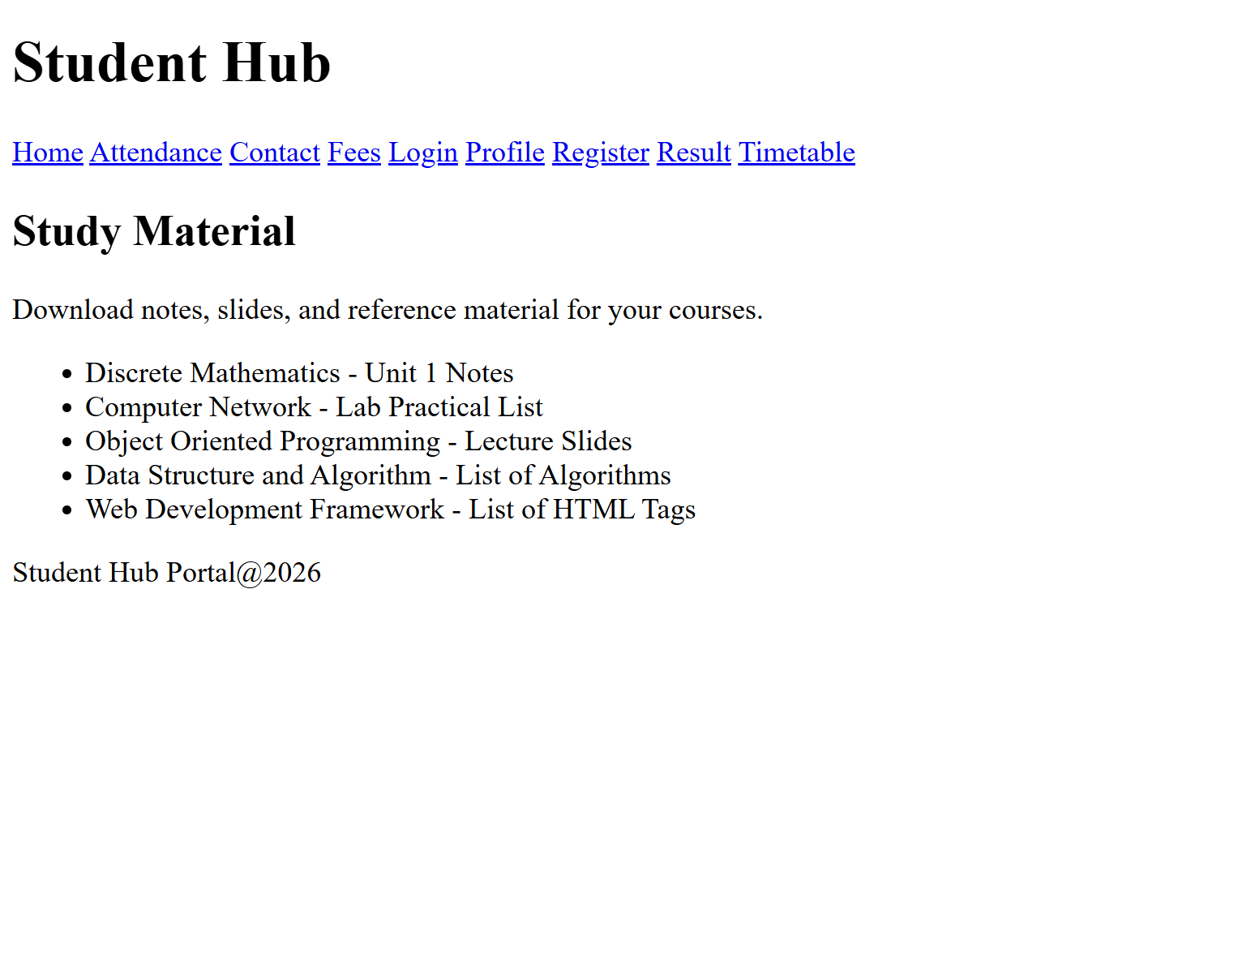

9)Profile Page:
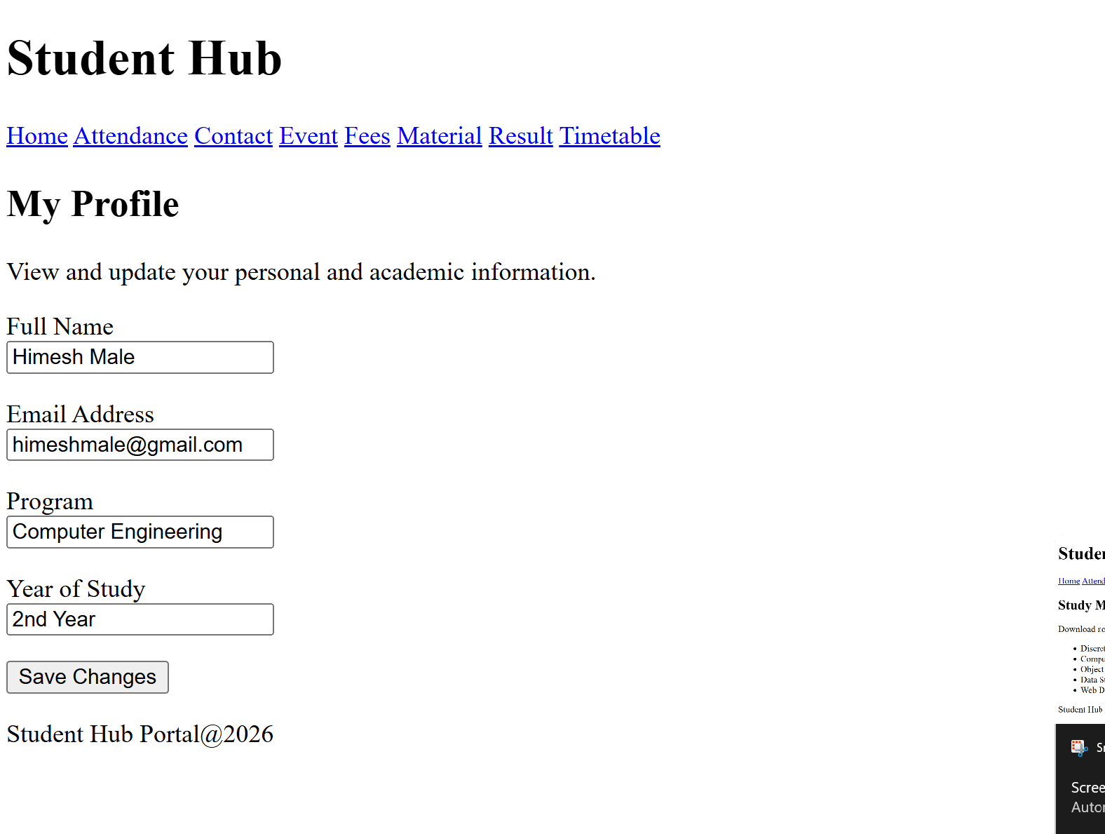

10)Timetable Page:
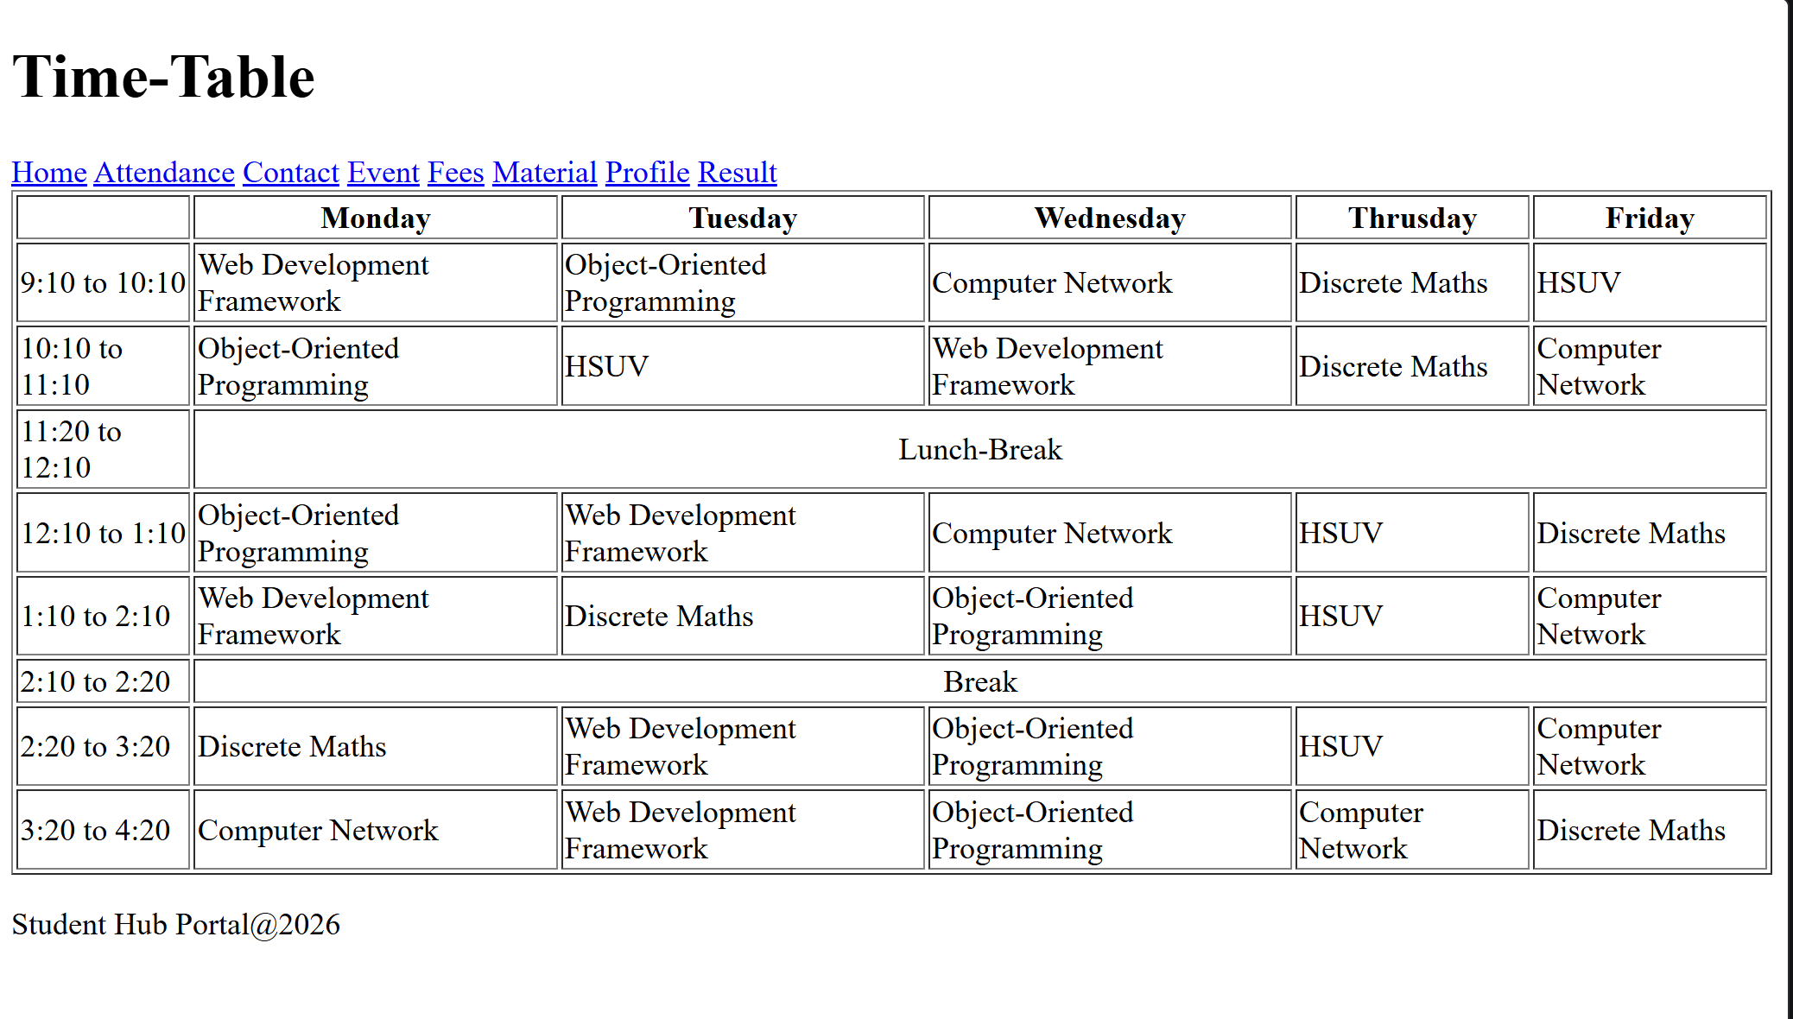

D.GitHub Repository Link: https://github.com/HimeshMale/Student-Hub-Portal.git

E. Challenge Faced :
I initially struggled with keeping the HTML structure uniform across all 10 pages while making sure each one still felt purposeful rather than repetitive. Deciding where to use section versus article versus aside also took some trial and error, since their purposes can overlap depending on the content. Making sure the navigation menu linked correctly to every page without broken links added another layer of care.

F. Learning Outcomes:
I learnt how to build a clean, semantic page skeleton using tags like header, nav, main, and footer that clearly communicate the purpose of each section of a page. I also picked up simple accessibility practices like writing meaningful alt text for images and properly linking form labels to their inputs.

Faculty Remarks:

